
Software Engineering Department
Capstone Project Phase B

Real Estate Price Evaluation Using Machine Learning

https://github.com/Asaad164/FinalProject.git

Supervisor: Dr. Reuven Cohen
Name | Asaad Sajim | Joul Hurani
ID | 212755367 | 212873723
E-mail | Asaad.Sajim@e.braude.ac.il | Joul.Hourany@e.braude.ac.il

Table of Contents
Index | Subject | Page number
 | Abstract | 3
‎1 | Introduction | 3
‎2 | Background and Related Work | 4
‎2.1 | The Necessity of Estimating Real Estate Prices | 4
‎2.2 | machine Learning algorithms | 5
‎2.2.1 | Decision Tree | 5
‎2.2.2 | The Random Forest model | 5
‎2.3 | R² Score | 6
‎3 | The project | 7
‎3.1 | Website | 7
‎3.1.1 | Activity diagram | 7
‎3.2 | Price Estimation Using Machine Learning | 8
‎4 | System Description | 8
‎4.1 | System Architecture | 8
‎5 | Machine Learning Model Design | 9
‎5.1 | Model Input and Output | 10
‎5.2 | Dataset | 10
‎5.3 | Model Training | 12
‎6 | System Implementation | 12
‎6.1 | Backend Functional Flow | 12
‎6.2 | Frontend User Workflow | 13
‎6.3 | Technical Features Summary | 13
‎7 | Challenges and Lessons Learned | 14
‎7.1 | Challenges Faced | 14
‎8 | Results | 15
‎8.1 | Model Accuracy | 15
‎8.2 | Price Prediction Range | 15
‎8.3 | Appraiser Insights & Feature Testing | 15
‎9 | Testing | 16
‎10 | Summary and Conclusions | 17
‎10.1‎ | Lessons Learned | 18
‎11 | References | 18
 | End of project book
‎1 | User Guide | 19
‎1.1 | Introduction | 19
‎1.2 | Website Usage | 19
‎1.3 | User Interface | 19
‎1.3.1 | Home Page | 19
‎1.3.2 | Estimate Page | 20
‎1.3.3 | Results Page | 21
‎1.3.4 | Help Page | 22
‎1.3.5 | About Page | 22
‎1 | Maintenance Guide | 23
‎1.1 | System Requirements | 23
‎1.1.1 | Backend (Server – ServerFlask folder) | 23
‎1.1.2 | Frontend (Client – real-estate-app folder) | 23
‎1.2 | Installation Instructions | 23
‎1.2.1 | Backend Setup – ServerFlask | 23
‎1.2.2 | Frontend Setup – real-estate-app | 24
‎1.3 | System Components | 24
‎1.3.1 | Backend Components | 24
‎1.3.2 | Frontend Components | 25
‎1.4 | Project Structure | 26
‎1.5 | Package Diagram | 26
‎1.6 | Modifying or Updating the System | 27

Abstract
This project presents a web-based platform for estimating real estate prices in the Israeli market using machine learning. Traditional property valuation methods often rely on subjective appraisals, which can vary significantly between professionals and take considerable time. To address these challenges, we developed an automated pricing system based on the Random Forest algorithm, a robust and widely used ensemble learning method. Random Forest improves accuracy by generating multiple decision trees and combining their outputs, making it especially effective for handling structured real estate data.
The platform focuses on reliable, high-impact features such as property area, number of rooms, location, year of construction, and property type, all derived from official datasets published by the Israel Tax Authority. After extensive testing and consultation with professional appraisers, optional features like parking, elevator, view, Proximity to schools, parks, and public transportation and Environmental hazard were removed, as they lacked consistent data and negatively affected model accuracy.
The system achieved an R² score of 0.84, indicating strong predictive performance. To reflect real-world variability, the predicted price is presented as a range (±8%) around the central estimate.
By providing accurate, transparent, and fast price estimates, this platform aims to support homebuyers, sellers, and real estate professionals across Israel and improve decision-making in the property market.
- Introduction
Estimating real estate prices is a complex task, as many factors can influence property value, including the location, area, number of rooms, construction year, and property type. Traditional price estimation methods often rely on professional appraisers who evaluate properties based on experience and judgment. While helpful, these methods can sometimes be inconsistent, subjective, and time-consuming. Different appraisers may assign different values to the same property, and the manual process makes it difficult to analyze large datasets and identify pricing trends.
This project addresses these limitations by developing a machine learning-based web platform that provides accurate and consistent real estate price estimates. The system is built using a Random Forest regression model, trained on official transaction data from the Israel Tax Authority. By learning from thousands of past property sales, the model identifies patterns between property characteristics and actual selling prices.
The platform focuses only on reliable, structured features such as property area, number of rooms, location (city and block), year built, and property type. Optional features like parking, elevator, and view were considered but removed after testing and consultation with real estate appraisers. These features lacked enough reliable data and negatively affected model accuracy.
The model achieved an R² score of 0.84, demonstrating strong predictive performance across different cities and property types. To enhance transparency, the system presents predictions as a price range, calculated as:
Price Range = Predicted Price ± 8%
This gives users a realistic understanding of price fluctuations in the market.
The platform features a user-friendly web interface where buyers, sellers, and real estate professionals can input property details and receive instant, data-driven price estimates. The system is fast, accurate, and lightweight, making it suitable for real-time use on standard servers.
By replacing subjective estimates with consistent, data-backed predictions, this platform modernizes the real estate pricing process in Israel and builds greater trust among users.

- Background and Related Work
  - The Necessity of Estimating Real Estate Prices
Estimating real estate prices is essential, as it plays a pivotal role in the decision-making processes of various stakeholders, such as buyers, sellers, investors, and financial institutions. Here are the main reasons why estimating real estate prices is necessary:
Informed Decision-Making: Accurate property valuations help buyers and sellers to make informed decisions. Buyers need to ensure that they pay a fair price, while sellers want to ensure they receive a proper return on their investment. Real estate professionals also require accurate pricing to advise their clients effectively.

Market Efficiency: Estimating real estate prices accurately ensures that the market stays efficient. If prices are consistently over- or under-estimated, it can lead to market distortions, where properties might be underpriced or overpriced. This problem can negatively affect market stability and investor confidence [1].

Financial Decisions and Risk Assessment: Lenders, such as banks and mortgage companies, rely on property valuations to determine the loan amount that they provide to buyers. Inaccurate valuations could lead to over-lending or under-lending, creating financial risk for both lenders and borrowers [2].

Investment and Development Opportunities: For investors, knowing the accurate value of properties helps them to find profitable investment opportunities.

Taxation and Legal Compliance: Governments and local authorities require accurate property valuations to set property taxes and assess the fair distribution of tax burdens. Furthermore, proper valuation is essential in legal cases related to property disputes, inheritance, or divorce.

Transparency and Trust: Providing transparent and data-driven property valuations helps to establish trust in the real estate market. When valuations are based on verifiable data instead of personal opinions or arbitrary judgments, it fosters confidence among stakeholders and promotes a fairer, more reliable market.

  - machine Learning algorithms

    - Decision Tree
A decision tree algorithm models decisions and their possible consequences in a tree-like structure. It uses a series of branching conditions based on the input features to classify or predict outcomes. Each branch represents a decision, and the endpoints, known as "leaves", provide the final decision or classification.
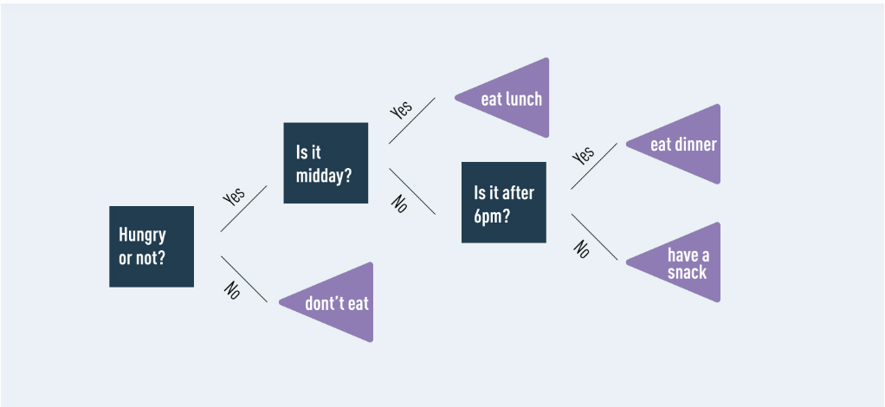
Figure 1: example of a simple decision tree

    - The Random Forest model
the random forest algorithm is based on the following principles: [3]
Multiple Trees for Better Accuracy: Random Forest grows multiple decision trees and uses all their predictions to improve accuracy.
Voting Mechanism (Classification): In the classification task, each decision tree in the forest makes a prediction. The final classification is based on the majority of the predictions from all trees.
Averaging Predictions (Regression): Random Forest averages the predictions from all the trees to make a final prediction.
Low Correlation Between Trees: A key advantage of Random Forest is that the individual decision trees are uncorrelated. When combined, the lowest predictions are removed, and the majority of the tree's predictions guide the model toward the correct prediction.
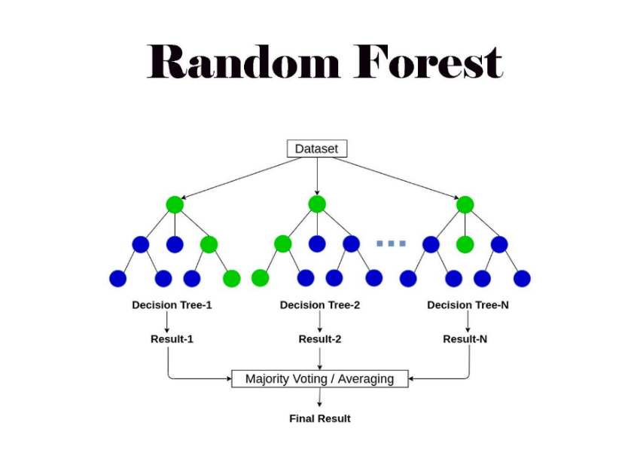
Figure 2: Random Forest algorithm

  - R² Score
In this project, we used the R² score to measure how well our model predicts property prices. R² is a common metric for regression models. It tells us how much of the variation in the target (selling price) can be explained by the input features (like area, rooms, and location).
- An R² of 1 means perfect prediction.
- An R² of 0 means the model is no better than just guessing the average.
This makes R² a reliable way to evaluate the performance of price prediction models like ours.

- The project
  - Website

To ensure easy and broad access to our real estate price estimation model, we developed a modular web-based platform that enables both scalability and ease of use. The website was built using the React framework for the client-side interface and the Flask framework for the backend, allowing seamless integration with the trained machine learning model.
The platform allows users to:
- Enter property details.
- Instantly receive an estimated market price.
This design offers a user-friendly experience for buyers, sellers, and real estate professionals, ensuring accurate and transparent pricing without relying solely on manual appraisals.

    - Activity diagram

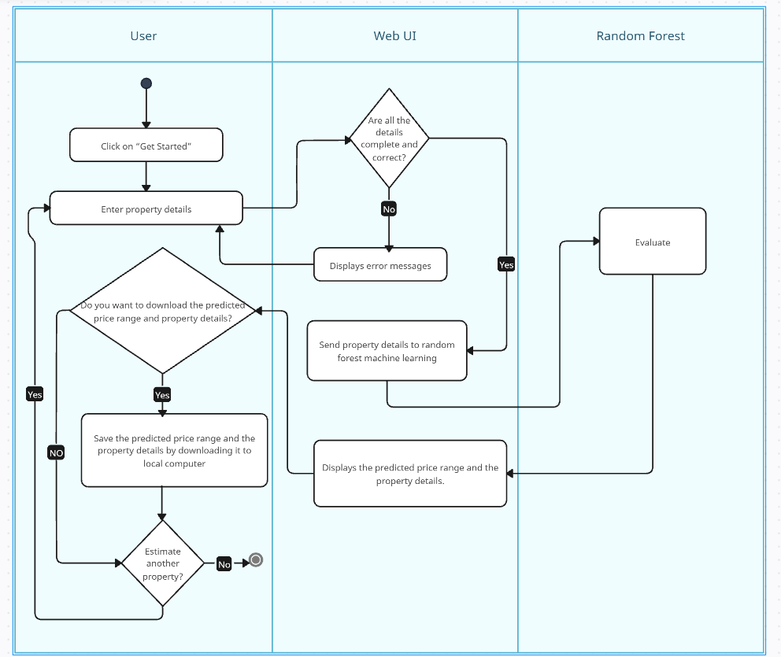
Figure 3: Activity Diagram

The activity diagram below illustrates the process of property price estimation in our system. The user begins by clicking on the "Get Started" button. This action leads them to enter the necessary property details. The Web UI then validates the details to ensure they are complete and correct.
If the details are incomplete or incorrect, the system displays error messages, prompting the user to make corrections.
If the details are accurate, the Web UI forwards the property information to the backend, where the random forest machine learning model processes the input data.
The random forest model evaluates the details and predicts the property's price. The predicted price range and the property details are displayed to the user through the Web UI. The user has the option to save it by downloading it to a local computer. Finally, the user can choose to estimate another property or exit the system.

  - Price Estimation Using Machine Learning

Our project utilizes a Random Forest regression model to estimate property prices in the Israeli real estate market. This choice was made due to its strong accuracy, interpretability, and performance with structured data.
The model was trained using real-world transaction data obtained from the Israel Tax Authority, containing thousands of property records from various towns.
We intentionally excluded additional user-provided features (e.g., parking, elevator, view, etc.) because they introduced noise into the model and reduced its prediction accuracy. By focusing only on reliable and consistently available data, we improved the model’s overall performance and reliability.

- System Description
The proposed system is a web-based platform for estimating real estate prices in Israel. It is built on a modular architecture that includes a React-based frontend, a Python Flask backend, and a machine learning model trained using scikit-learn. Data is retrieved.
  - System Architecture
The system is composed of three core components:
Frontend (Client-Side): Developed using React.js, the frontend provides a responsive and intuitive user interface. It handles form interactions, displays the results, and communicates with the backend using HTTP requests.
Backend (Server-Side): Implemented with Flask in Python, the backend receives requests from the frontend, handles data preprocessing, and interacts with the trained machine learning model to generate predictions.
Machine Learning Model: A Random Forest Regressor trained on real estate transaction data. It receives structured input features and returns a predicted price range.
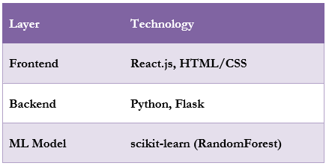
Figure 4: System Technology Overview

- Machine Learning Model Design
The core of the system is a supervised machine learning model designed to estimate property prices based on structured input data. After evaluating several algorithms, including linear regression, gradient boosting, and neural networks, we selected Random Forest Regression for its balance of accuracy, interpretability, and performance on tabular data.
Why Random Forest?
Random Forest is a machine learning algorithm that will be utilized in this project to predict real estate prices. Random Forest is particularly effective for handling structured data, such as property attributes, and provides reliable predictions even in complex scenarios.
Random Forest has been chosen for this project due to several key strengths:
High Accuracy: By averaging the predictions of multiple decision trees, Random Forest reduces overfitting and provides more stable and accurate results.
Robustness: It handles a wide variety of data types, including numerical and categorical variables, and is resistant to noise and missing values.
Feature Importance: Random Forest ranks the importance of input features, helping to identify which property characteristics (e.g., size, location, amenities) have the most significant impact on pricing.
Scalability: The algorithm can process large datasets efficiently, making it suitable for analyzing extensive real estate records.
  - Model Input and Output
The model takes the following structured features as input:
Property size
Number of rooms
Year built
Date of Sale
City (Haifa, Nahariya, Karmiel)
Property type (apartment, duplex cottage, garden apartment, single-family cottage)
Block number (simplified to first five digits)
Sold Part (1 = the whole apartment)
Computed features: age property, room density (Property size/Number of rooms)

The model results:
A predicted selling price in New Israeli Shekels (NIS), based on the input property details.
To improve clarity and reflect real-world uncertainty, the system presents the result as a price range, calculated as:
Predicted Price ± 8%
This allows users to better understand market variability and make more informed pricing decisions.

  - Dataset
The dataset used in this project is sourced from "Israel Tax Authority", an official Israeli government website that provides publicly available information on real estate transactions. This dataset serves as a crucial foundation for our project, as it includes comprehensive details about property sales across Israel.
Structure of the dataset
The data set includes the following information on real estate:
Number of Rooms, the Area, the Year Built, the city, the Type (apartment, single-family home, community housing, etc..), the Price, and the block and parcel number.
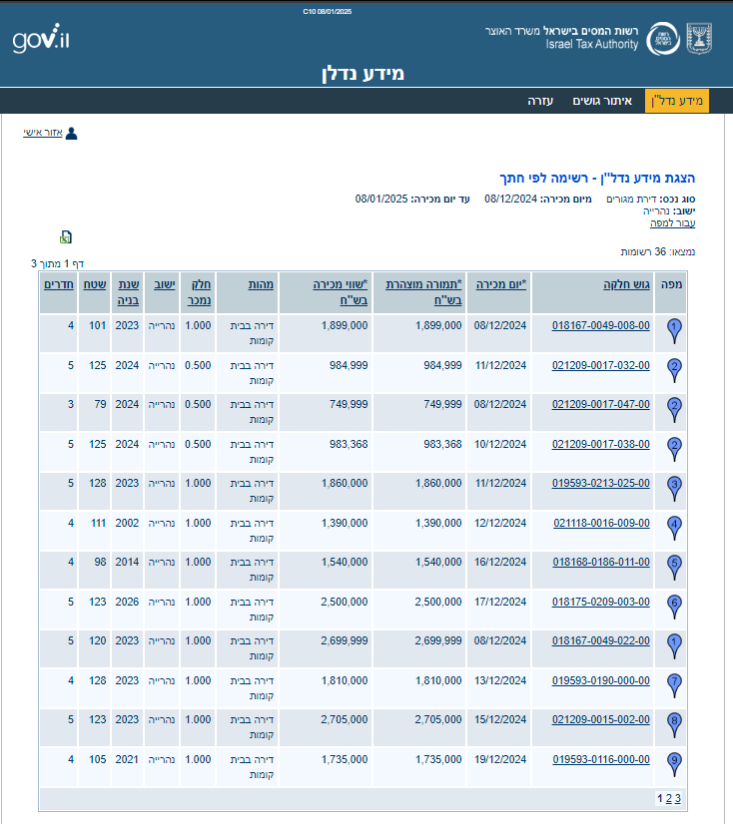
Figure 5: Dataset Structure Example

The dataset was downloaded as an Excel file directly from the website.
In total, we used about 2,179 transaction records, taken from data between 2024 and 2025, we decided not to include older data from previous years because real estate prices have changed a lot over time, that could confuse the model and lower its accuracy, since the prices back then were very different from today.
The cities we focused on were Haifa, Nahariya and Karmiel. We picked these places because they had enough available data and covered different types of areas and properties, which helped the model learn better.

  - Model Training
The training process included the following steps:
Data Splitting: The dataset was divided into 80% for training and 20% for testing using train_test_split, ensuring proper model validation.
Model Training: The model was trained using the processed feature set (X_train) and the corresponding property prices (y_train).

- System Implementation
The project was implemented as a full-stack web application with two main components: the frontend (user interface) and the backend (logic, model execution, and data processing). The machine learning model is embedded in the backend and is used in real-time to predict housing prices based on user inputs.

  - Backend Functional Flow
Step | Description
1 | Flask server receives property input from the frontend via a POST request
2 | Applies preprocessing (e.g., date parsing, property age calculation)
3 | Evaluate the data and predict results using the trained Random Forest model
4 | Returns the predicted price as JSON format to the frontend system

  - Frontend User Workflow
Step | User Action | System Behavior
1 | Fill in property form | Validates inputs (area, rooms, city, etc.)
2 | Submit form | Sends data to backend via HTTP request
3 | Wait a few seconds | Receives and displays predicted price range on the screen
4 | Optional: Clear or re-enter data | Repeat the estimation process

  - Technical Features Summary
Feature | Implementation Detail
Real-time communication | HTTP POST requests between React and Flask
Prediction logic | In-memory Random Forest model (no reloading delay)
Scalability | Modular separation of frontend/backend for future upgrades
Security | No user accounts or sensitive data; backend logic only exposed

- Challenges and Lessons Learned

Throughout the development of the real estate pricing platform, we faced a variety of technical, analytical, and domain-specific challenges. Each required a strategic solution, combining data analysis, model validation, and professional consultation. The result is a smarter, more robust, and more generalizable system.

  - Challenges Faced
Challenge | Description | Solution
Additional Features: Reduced Accuracy | We evaluated the inclusion of features such as parking, elevator, view, and proximity to services. Despite extensive testing and consulting with real estate appraisers, we found that these features introduced noise into the model and reduced its prediction accuracy. | These features were intentionally removed to preserve model stability and improve cross-regional performance. By focusing only on core, reliable inputs, we achieved better accuracy and consistency.
Inconsistent Data Formats | The original dataset had varying formats for dates and numeric fields, which complicated preprocessing and model training. | We applied systematic preprocessing including: date parsing, numeric conversion, and removal of corrupted or unparseable rows.
Overly Granular Block Information | Using the full Block and Parcel Number made the data too sparse, treating nearby homes with similar value as unrelated. | We extracted only the first four digits of the block number, effectively grouping geographically similar properties for more coherent modeling.
Balancing Simplicity vs. Accuracy | Adding more features did not always improve results. Some complex inputs introduced noise, making the model harder to generalize. | We prioritized high-quality structured features (e.g., area, rooms, age, city) and engineered new features (e.g., room density) that improved predictive performance.

- Results
The effectiveness of our real estate pricing platform is measured by its predictive accuracy, reliability across regions, and the interpretability of its features. After extensive training, testing, and consultation, we achieved robust results that validate the technical and practical value of our system.

  - Model Accuracy
Our model achieved an R² score of 0.84 on the test set. This means it was able to explain 84% of the variation in property prices based on the selected input features. The result reflects strong predictive performance and generalization across different cities and property types.
  - Price Prediction Range
To reflect model uncertainty transparently, we implemented a ±8% prediction margin around the central price estimate. This range accounts for natural price fluctuations in the real estate market.
Price Range = Predicted Price ± (Predicted Price × 0.08)
Example: ₪1,000,000 → range from ₪920,000 to ₪1,080,000

  - Appraiser Insights & Feature Testing
To enhance the realism of the model and align it with real-world pricing practices, we collaborated with certified real estate appraisers. Based on their expertise, we identified several commonly used valuation factors in the field, including:
Parking availability
Elevator presence
view
Proximity to schools, parks, and public transportation
Environmental hazard
We attempted to incorporate these features into the model by engineering new variables and testing their impact on accuracy. However, during this process, we faced two major limitations:
Lack of Reliable Transactional Data:
While we consulted appraisers and gathered a small number of annotated real transactions, we were unable to collect enough real transactions. This made it difficult to calculate meaningful statistical weights for those variables.
Negative Impact on Model Accuracy:
When we tested the engineered features in the model, they introduced instability and reduced accuracy.

Because of these reasons, we decided to remove these features from the final model. This made the system simpler, more stable, and more accurate across all cities.

- Testing
Case | Test Case | Expected Result | Results
1 | Press "Get Started". | The user is taken to the next page (Estimate page). | Passed
2 | Entering the necessary property details correctly and completely and Press” Estimate Price”. | The system accepts the details and proceeds to estimate the property price, the result (price + impact factors) is displayed to the user. | Passed
3 | Entering the necessary property details not correctly or not completely and Press” Estimate Price”. | Error is shown:  “The property details you entered are incomplete or incorrect. Please review the information and try again. ” | Passed
4 | Press "Estimate another property" | The user is taken to the Estimate page to start a new estimation. | Passed
5 | Access Help & FAQ | The system redirects the user to the Help & FAQ section. | Passed
6 | Return to the main page | The system redirects the user to the home page. | Passed
7 | No result output in the final step | Error is shown:  “An error occurred while evaluating the property details. Please try again.” | Passed
To evaluate the platform beyond technical accuracy, we conducted user testing with 11 individuals, including 4 students, 4 property owners, and 3 licensed real estate appraisers. Testers were asked to input real property details and compare the platform’s price estimates with known sale prices or professional opinions.
The feedback was largely positive, highlighting:
- The ease of use of the interface
- The speed and clarity of the results
We also asked users if they would prefer to have a login system so they could save past evaluations to their account. The unprofessional users, i.e., students and property owners mostly responded that they would probably use the tool just once or twice, so they did not want to create an account. The appraisers said that the form is short and easy to fill again, and that they prefer to save their results locally on their own computer rather than using a website account.
Based on this feedback, we understood that it is better to keep the platform simple and instead offer a downloadable report. So, the system allows users to download the prediction result as a file, which includes the entered property data, the predicted price range, and a name they choose for that specific evaluation (to help them remember which property it was).

- Summary and Conclusions

- This project demonstrated that machine learning — specifically the Random Forest algorithm — can serve as a fast, reliable, and objective alternative to traditional real estate appraisals. Unlike manual methods that depend on subjective human judgment, our model uses real data to deliver consistent, data-driven predictions.

- Choosing the right features had a major impact on model performance. After working with both real data and expert feedback from appraisers, we learned that adding too many features (like view, elevator, etc.) without enough reliable data can hurt accuracy. Focusing on core, structured features, such as property size, number of rooms, year built, and location, resulted in a more stable and accurate model.

- The system can be further improved if a large number of complete real transactions becomes available. With sufficient high-quality data, we could reintroduce features such as parking, elevator, view, and proximity to services, and determine their true statistical weight, which may further enhance accuracy.

- The platform is designed with future evolution in mind. Its architecture allows for continuous improvement, including the integration of additional real estate data sources, expansion to new geographic regions across Israel, and regular updates to the machine learning model as new transaction data becomes available. These enhancements will help maintain the system’s accuracy and relevance in a dynamic and fast-changing real estate market.

  - Lessons Learned
- More Features ≠ Better Results
The inclusion of more features does not automatically improve accuracy. Careful feature selection based on real-world impact and consistency was more effective.
- Expert Feedback Adds Real-World Value
Working with licensed real estate appraisers helped to bridge the gap between technical design and practical market behavior, especially in understanding how block codes relate to pricing zones.
- Computed Features improve Results
Features like room density added measurable value. It was not part of the raw data but significantly enhanced the model’s learning ability.
- Clear Output Builds Trust
Presenting the output as a price range (±8%) made the system more transparent and aligned with how real estate professionals think, acknowledging natural price variability.

- References

[1] The Investopedia Team. (2022). Market efficiency. Investopedia. Reviewed by M. J. Boyle. Fact-checked by J. Ma. https://www.investopedia.com/terms/m/marketefficiency.asp
[2] Li Cain, S. (2024, November 11). Home appraisal vs. home inspection: What’s the difference? Bankrate. https://www.bankrate.com/real-estate/home-appraisal-vs-inspection/
[3] Rachel Meltzer. (31 August 2023). What Is Random Forest?. Careerfoundry. https://careerfoundry.com/en/blog/data-analytics/what-is-random-forest/#what-is-random-forest

- User Guide

  - Introduction

This section serves as a user guide for our web application, a machine learning based system designed to estimate real estate property prices based on user provided information. The platform uses a trained predictive model to generate price estimates based on factors such as Property Size (m²), Number of Rooms, Year Built, Block Number, Date of Sale, City, Property Type, Sold Part.
To use the application, users only need a modern web browser. The system is designed to be intuitive and accessible for both general users and real estate professionals seeking quick property evaluations.

  - Website Usage

The application is available online at: https://real-estate-estimator.vercel.app/

Once the website is opened, users are presented with a clean interface that includes a property input form.
Users can enter details such as Property Size (m²), Number of Rooms, Year Built, Block Number, Date of Sale, City, Property Type, Sold Part.
After filling out the form, the user can click the Predict button. The data is then sent to the server, which processes the input using the trained machine learning model. The estimated property price range is then displayed along with a summary of the entered property information.
The prediction system works entirely online and does not require any prior registration or login, this ensures ease of use.

  - User Interface
    - Home Page
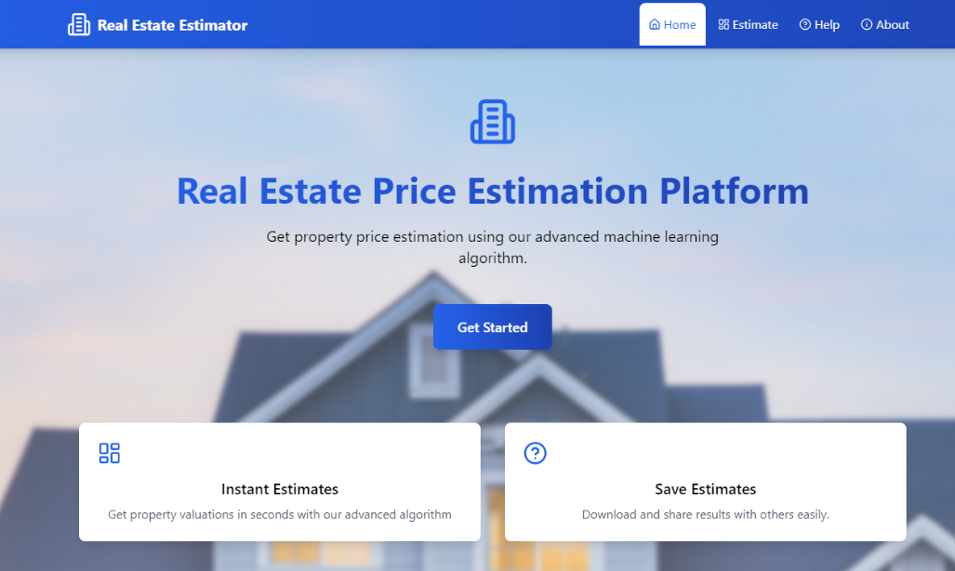
When you open the platform, you will land on the Home page. It gives a short explanation of what the system does and highlights its features: instant price estimates and the ability to save results. To start, click the “Get Started” button or go to the Estimate tab.
Figure 6: Home page
    - Estimate Page
On the Estimate page, you will find a form titled Property Details. Fill in the required information about the property:
- Size (in square meters)
- Number of rooms
- Year built
- Block number
- Date of sale
- City
- Property type
- Sold part (e.g. 1 = entire property)
- House Name (only if you want to mark this estimation so you remember which property is it)
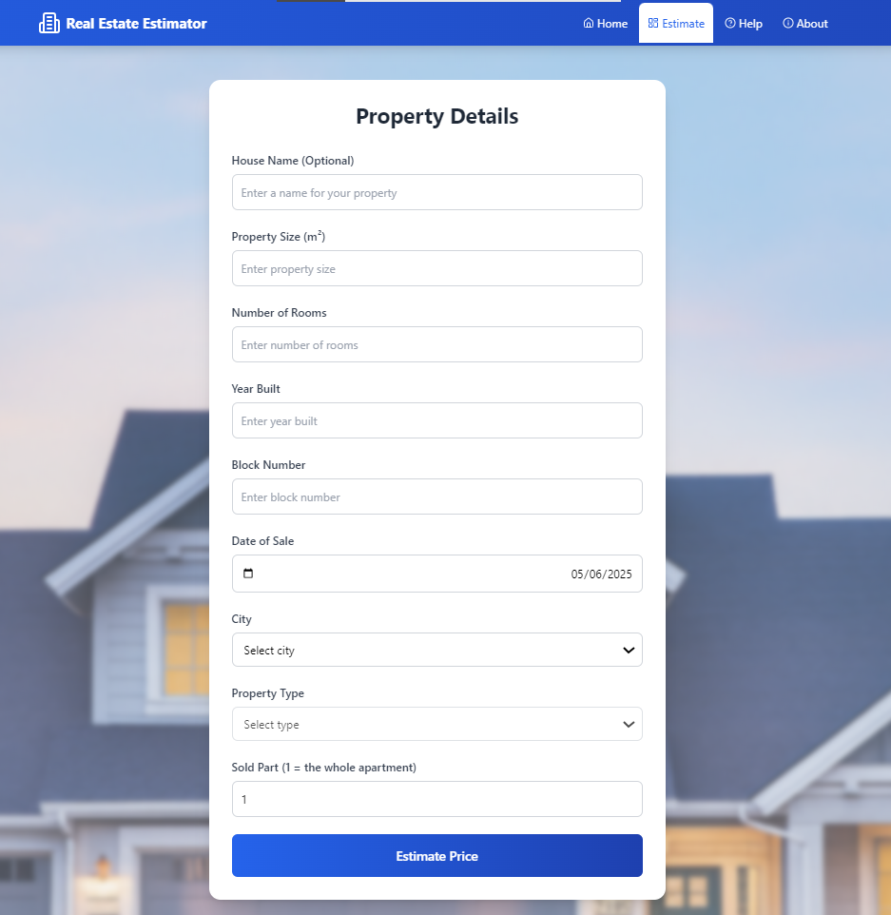
After completing the form, click the “Estimate Price” button at the bottom to get your prediction.
Figure 7: Estimate page
    - Results Page

Once the system processes your input, you will be taken to the results page. It shows a summary of the property details you entered, a predicted price range based on the trained machine learning model. You can then choose to download Estimate Details as a file or Estimate Another Property if you want to repeat the process.

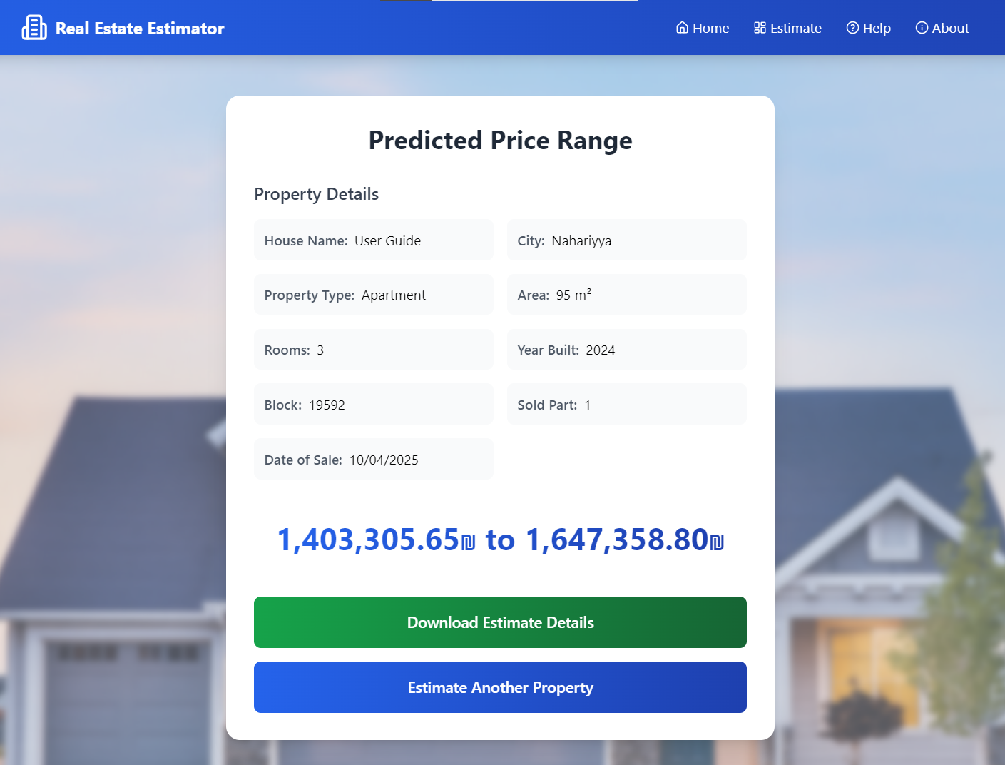
Figure 8: Results page

    - Help Page
If you are unsure how to use the platform, go to the Help tab. You will find a quick explanation of how the platform works; a list of the information you need to enter and contact info in case you need support.
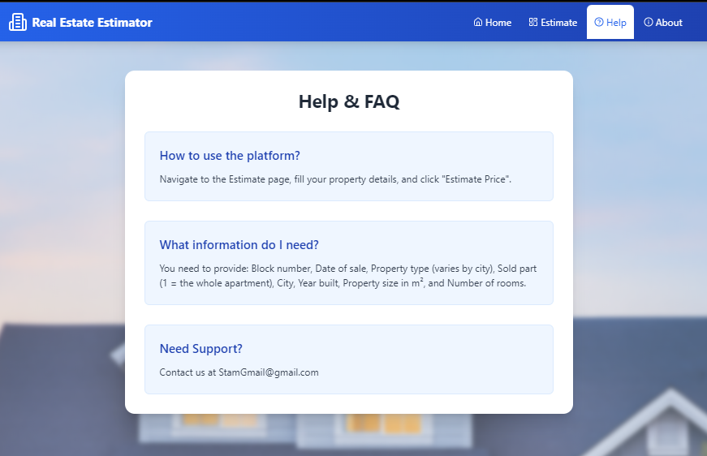
Figure 9: Help page
    - About Page

The About page explains the goal and technology behind the platform. It covers the purpose of the project, how the system works, the cities and property types supported, key features of the platform and the creators of the platform.
Figure 10: About page
- Maintenance Guide
  - System Requirements
    - Backend (Server – ServerFlask folder)
- Language: Python
- Python version: 3.12 or higher
- Main file: server.py
- Model file: apartment_price_model.pkl (pre-trained machine learning model)
- Required Libraries (installed via requirements.txt):
  - Flask
  - Flask-cors
  - pandas
  - joblib
  - scikit-learn
    - Frontend (Client – real-estate-app folder)
- Framework: React.js
- Styling: Tailwind CSS (configured via index.css)
- Node.js version: v16 or higher
- Bundler: Vite
- Required Dependencies (installed via npm install):
  - react, react-dom, lucide-react
  - tailwindcss, vite and development tools (eslint, postcss, etc.)

  - Installation Instructions
This project includes two main parts:
- Backend (Python server) located in the ServerFlask folder
- Frontend (React app) located in the real-estate-app folder
    - Backend Setup – ServerFlask
  - Download the folder:
Go to the GitHub repository:
https://github.com/Asaad164/FinalProject.git
Download or clone the ServerFlask folder.
  - Open a terminal in the ServerFlask folder.

  - Install required Python packages.
Run:
pip install -r requirements.txt
  - Make sure the trained model is available.
The file apartment_price_model.pkl must be in the same folder as server.py.
  - Run the server.
Run:
python server.py

    - Frontend Setup – real-estate-app
- Download the folder:
Go to the GitHub repository:
https://github.com/Asaad164/FinalProject.git
Download or clone the real-estate-app folder.
- Open a terminal in the real-estate-app folder.
- Install frontend dependencies.
Run:
npm install
- Start the website.
Run:
npm run dev

  - System Components
    - Backend Components
- app.py – Flask Server
- Purpose: Real estate price prediction system
- Main functions:
  - Load pre-trained ML model
  - Receive property data from the client
  - Process and normalize data
  - Generate price prediction
  - Return price range
- apartment_price_model.pkl
- Purpose: Trained machine learning model
- Input: Property data (Area, rooms, year built, year built, block, sale date, city, property type, sold part)
- Output: Predicted property price

    - Frontend Components
- App.jsx – Root Component
- Purpose: Manage page navigation
- States: Current page, estimated price, form data
- Navigation.jsx
- Purpose: Responsive navigation menu
- Pages: Home, Estimator, Help, About
- PropertyForm.jsx
- Purpose: Form for entering property data
- Fields: Area, rooms, year built, block, sale date, city, property type, sold part.
- Validation: Data integrity checks
- ResultsPage.jsx
- Purpose: Display prediction results
- Functions: Download estimate report, estimate another property
- AboutPage.jsx
- Purpose: Provides background information about the platform
- HelpPage.jsx
- Purpose: Offers user guidance and answers common questions
- HomePage.jsx
- Purpose: Introduces the platform.
- main.jsx
- Purpose: Initializes and renders the React application

  - Project Structure
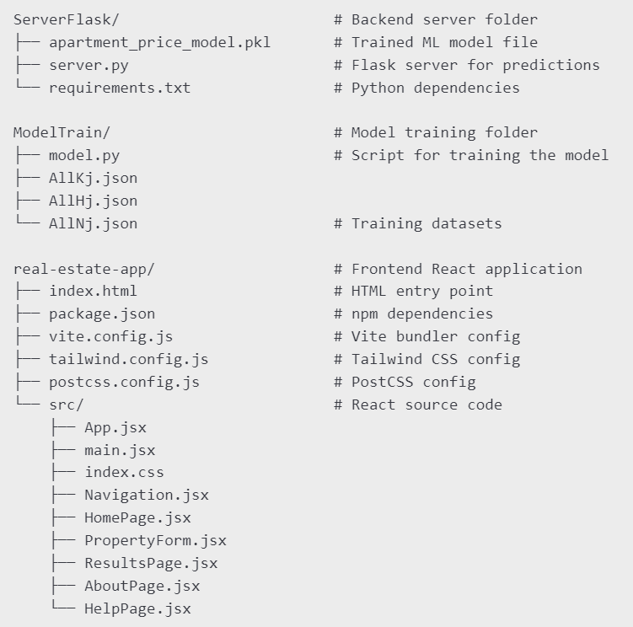
Figure 11: Project Structure Diagram

  - Package Diagram
The diagram below shows the structure of our real estate prediction system. It includes different parts of the project like the user interface (UI), the server that handles predictions, the machine learning model, and the saved model file. Each part contains its main components and the functions they use.
The lines show how the parts are connected and how they work together.
The UI sends data to the server, the server uses the trained model to predict, and the training process creates the model file.
The line PropertyForm to data shows that this form collects the input data from the user. The line from data to ResultPage shows that the result page uses the same property data to display a summary of the input alongside the predicted price. The line from Server to apartment_price_model shows from where the server gets the trained model file to make predictions. The line from model to apartment_price_model shows that after the training process the model file created and saved to be used by the server.

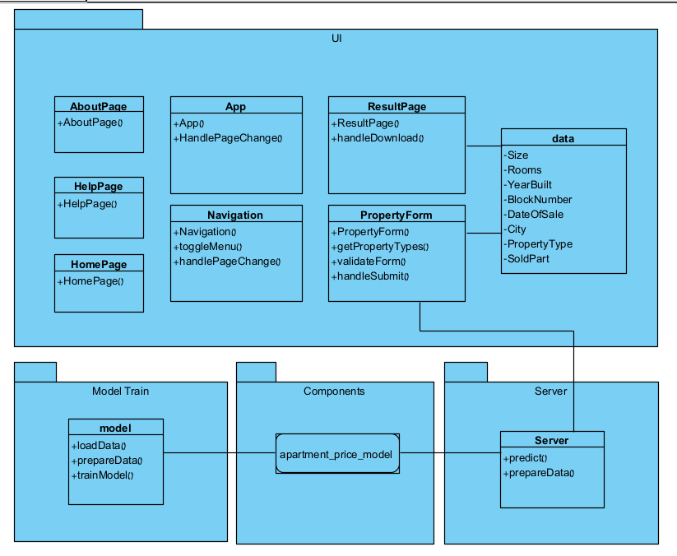
Figure 12: Package Diagram

  - Modifying or Updating the System

- Add More Cities

There is already a folder in the GitHub repository named ModelTrain with a file called model.py that contains building and training the model.
To add a new city, you only need to provide a data for this city (you can find from Israel tax authority website), each house in the data should look like this:

{
"Block": <block>,
"Date of sale": <date of sale>,
"Selling price in NIS": <price of property>,
"Type": <type of house (apartment, ...)>,
"Sold part": <sold part>,
"City": <city>,
"Year Built": <year the house has been built>,
"Area": <area in $m^{2}$>,
"Rooms": <number of rooms>
{

Once you prepare a JSON file with similar structure and enough samples (at least 500–1000), use the code in M.py to merge it with your current data, retrain the model, and save it again as apartment_price_model.pkl. Then replace the old model file in the ServerFlask folder.

- Improve Accuracy with Real-Time Data
To make the platform more accurate and up to date, we recommend contacting the Israeli Tax Authority to request access to their real estate transaction data.
If you can get real-time or monthly sales data directly from their systems, you can automatically update your dataset every month and retrain the model with new data to improve prediction quality.
Keep in mind that training takes time and system resources, so it is recommended to automate this process only once per month or based on needs.

